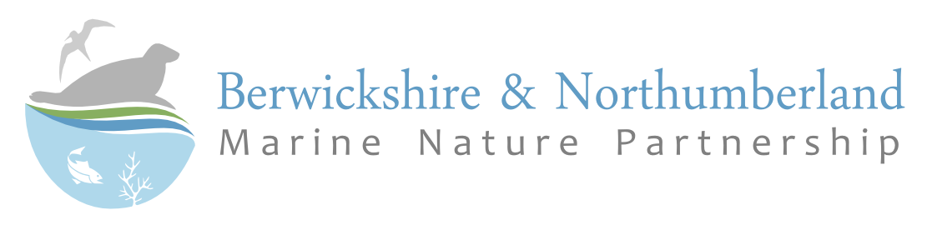

Student Bursary Award 2026

The Berwickshire and Northumberland Marine Nature Partnership is a partnership of nearly thirty organisations working to conserve and promote the sustainable use of the seas in Berwickshire, Northumberland and North Tyneside. We work to coordinate management activity on important marine areas and raise awareness of the pressures that they face. As part of our ongoing activities we have an annual bursary scheme to help support the cost of student dissertation projects which further the knowledge base in our area of operation.

Eligibility
All further education students, irrespective of the institution, may apply for the award as long as they meet the bursary criteria. The scheme is eligible for both undergraduate and post-graduate dissertation projects. The prime criteria is that the geographical area covered by the dissertation must coincide, either totally or partially, with that of the Berwickshire and Northumberland Marine Nature Partnership (the River Tyne in England to Fast Castle Head in Scotland). The project would have to be on a coastal/marine topic or theme that furthers the knowledge base in the Marine Nature Partnership area. Please see our research needs list for ideas (provided at end of the application form).

What we will Fund
The award will pay for essential travel and research expenses, such as laboratory or equipment costs up to a limit of £300 per project, payable on receipt of the final dissertation. Evidence will need to be provided before payment, including scanned receipts, and mileage for any travel expenses.

How to Apply
Students need to fill in the relevant application form, which can be downloaded at this link
A group of academics and Marine Nature Partnership members will judge and allocate the Awards.

Conditions
For those who are successful in their application, a condition of the funding will be that the Berwickshire and Northumberland Marine Nature Partnership will receive an electronic copy of the final dissertation.

Timetable
Proposals must be submitted by the 27th April 2026.

Submission
All forms or enquiries to be submitted to: nick.brodin@northumberland.gov.uk

