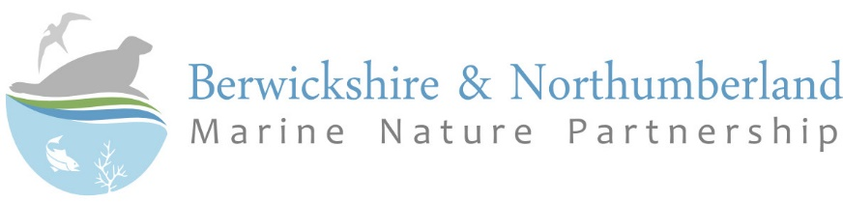

Summary of Roles and Responsibilities for MPA management in England

Responsibilities of individual organisations

Organisation | Responsibilities in MPA Management
Defra | Provide the overall MPA management policy framework
Joint Nature Conservation Committee (JNCC) | Statutory conservation adviser to UK Government and the Devolved Administrations for offshore areas (12-200 nautical miles)  Development of conservation objectives and advice on operations/activities in offshore MPAs.
Natural England | Development of conservation objectives and advice on operations/activities for inshore SACs, SPAs and MCZs  Management of Sites of Special Scientific Interest (SSSIs), including issuing of consent/assent for potentially damaging activities  Reporting on condition of SSSIs and inshore MPAs  Statutory conservation adviser to Government for inshore areas (0- 12 nautical miles)  Provide advice to relevant authorities regarding the scope of appropriate assessment needed for proposed plans or projects under the Conservation of Habitats and Species Regulations 2017  Statutory consultee on local plans and planning applications  Issue and enforce wildlife licences for the disturbance, taking or harm to Schedule 1 breeding birds and terrestrial protected species
Environment Agency | Management of migratory fisheries (e.g. salmon or trout) out to 6 nautical miles [NB: within the Tweed and Eye Fisheries district this is regulated by the River Tweed Commissions]  Competent authority for WFD estuarine and coastal waters to 1 nautical mile for ecological status and 12 nautical miles for chemical status  Issuing of permits for industrial processes and discharges to the environment  Managing the risk of flooding estuaries and the sea  Monitoring of water quality and bathing waters  Statutory Consultee on planning applications and local development plans
Marine Management Organisation | Licencing the deposition or removal of materials from the seabed (marine licences)  Issue and enforce wildlife licences for the disturbance, taking or harm marine protected species  Powers to make byelaws to control activities to protect MPAs (including fisheries and recreation). Note: Management of fishing activities is primarily between 6 and 12nm from the coast (but can implement measures in 0-6nm)  Development of marine plans  Advice on the use of dispersal agents and chemicals in the event of marine pollution emergencies  Fisheries management (6-12 nautical miles), including ensuring compliance with fisheries regulations (fishing vessel licences, time at sea and quotas for fish and seafood)
Local Authorities | Local Planning Authority dealing with Local Development Plan production and with Development Control down to Low Mean Water  Local emergency response planning for oil and chemical spills  Lead Local Flood Authority  Beach management and maintenance  Waste management and waste collection
Inshore Fisheries Conservation Authorities (IFCAs) | The sustainable management of inshore sea fisheries resources out to 6 nautical miles  Enforcement of inshore fisheries legislation  Data and evidence gathering to support fisheries management  Powers to make byelaws to control fishing activities to protect MPAs (activities include commercial fisheries and recreational fishing activities such as sea angling and bait digging).
Water companies  [Northumbrian Water] | Collection treatment and discharge of domestic sewage  Licencing discharge of trade effluent to a sewer
Harbour Authorities [within the meaning of the Harbours Act 1964(2)] | Maintaining and conserving the harbour facilities and ensuring safe and efficient marine operations  Maintenance of lights and navigational markers  Development of Harbour Pollution Incident Contingency Plans  Production of Harbour Waste Management Plan and provision of waste disposal facilities
General Lighthouse Authority (Trinity House) | Remit to provide aids to navigation and assist the safe passage of vessels
Maritime and Coastguard Agency (MCA) | Production of ‘The National Contingency Plan - A Strategic Overview for Responses to Marine Pollution from Shipping and Offshore Installations’  Coordination of national marine pollution responses  Sign-off on Local Pollution Incident Contingency Plans  Inspection and certification of vessels and monitoring compliance with the MARPOL Convention
River Tweed Commission | Management of migratory fisheries (e.g. salmon or trout) in the Tweed and Eye Fisheries District (an area just north of Cocksburnspath in Berwickshire down to just north of Holy Island in Northumberland and out to 5km offshore)

General Duties on all Public Authorities

Duty | Legislation
General duty on Competent Authorities (any Minister of the Crown government department, statutory undertaker, public body of any description or person holding a public office) to have regard to the EC Habitats Directive and Wild Birds Directive in the exercise of any of their functions | The Conservation of Habitats and Species Regulation 2017
Statutory duty on Public Authorities to take reasonable steps to conserve and enhance the special features of Sites of Special Scientific Interest (SSSIs) | Wildlife and Countryside Act 1981 (as amended)
Statutory Duties on Public Authorities to exercise their functions in a way to further (or where this is not possible least hinder) the conservation objectives for MCZs | The Marine and Coastal Access Act 2009 (Section125)
Statutory duty to consider the effect of proposed activities on MCZs before issuing any authorisation | The Marine and Coastal Access Act 2009 (Section126)
Statutory duty on Public Authorities to have regard to the purpose conserving biodiversity while carrying out their functions | Natural Environment and Rural Communities Act 2006 (section 40)

